**Retail Management System**

**Second Year Mini Project**

**In**

**Electronics and Computer Science**

By

**Anugu Navin Reddy (9815)**

**Anugu Vishnuvardhanreddy (9816)**

**Craig Zalake (9875)**

Under the guidance of

**Prof Dipali Koshti**

**(Designation of the guide)**



DEPARTMENT OF COMPUTER ENGINEERING

**Fr. Conceicao Rodrigues College of Engineering, Bandra (W), Mumbai - 400050**

University of Mumbai

(2023-24)

**Internal Approval Sheet**

**CERTIFICATE**

This is to certify that the project entitled **"Retail Management System"** is a bonafide work of **Anugu Navin Reddy(9815), Anugu Vishnuvardhanreddy(9816) and Craig Zalake(9875)** submitted to the University of Mumbai in partial fulfillment of the requirement for the termwork submission of Mini project for Second Year in  **Electronics and** **Computer Science.**

**(Prof. Dipali Koshti)**

Supervisor/Guide

**(Dr. Sapna Prabhu) (Dr. Surendra Singh Rathod)**

Head of Department Principal

**Approval Sheet**

**Project Report Approval**

This project report entitled Project **Retail Mangement System** by **Anugu Navin Reddy(9815), Anugu Vishnuvardhanreddy(9816), Craig Zalake(9875)**is approved for the termwork submission of Mini project for Second Year in Electronics and Computer Science.

Examiner 1. Prof Dipali Koshti

Examiner 2. __________________

Date:

Place:

**Declaration**

We declare that this written submission represents our ideas in our own words and where others’ ideas or words have been included, we have adequately cited and referenced the original sources. We also declare that we have adhered to all principles of academic honesty and integrity and have not misrepresented or fabricated or falsified any idea/data/fact/source in my submission. We understand that any violation of the above will be cause for disciplinary action by the Institute and can also evoke penal action from the sources which have thus not been properly cited or from whom proper permission has not been taken when needed.

**Anugu Navin Reddy(9815)**

**Anugu Vishnuvardhanreddy(9816)**

**Craig Zalake (9875)**

# Abstract

The Retail Management System (RMS) is a project designed to revolutionize the retail industry. This comprehensive software solution offers a unified platform to streamline and optimize retail operations, from efficient point-of-sale management to robust inventory control. RMS empowers retailers to provide superior customer service, adapt to changing market conditions, and harness the potential of data-driven decision-making. In an era where the boundaries between physical and online retail are blurring, the implementation of a robust RMS is pivotal for success, enabling retailers to stay competitive and embrace innovation.

The inventory management module enables retailers to efficiently manage their inventory levels by tracking stock levels, monitoring product movements, and automating reordering processes. By providing real-time insights into inventory status, this module helps retailers minimize stockouts, reduce overstocking, and optimize their supply chain operations. Additionally, the system offers advanced analytics capabilities to forecast demand, identify trends, and make data-driven decisions to enhance inventory efficiency.

Furthermore, the retail management system includes robust CRM functionalities to enable retailers to build and maintain strong relationships with their customers. By capturing and analyzing customer data, including purchase history, preferences, and behavior patterns, retailers can personalize marketing efforts, offer targeted promotions, and provide superior customer service. Moreover, the POS module facilitates smooth and secure transactions, supporting various payment methods and enabling retailers to process sales efficiently while ensuring a seamless checkout experience for customers. Overall, this retail management system empowers retailers to enhance operational efficiency, optimize inventory management, and deliver exceptional customer experiences in today's competitive retail landscape.

**Anugu Navin Reddy (9815)**

**Anugu Vishnuvardhanreddy(9816)**

**Craig Zalake (9875)**

Date:

**Acknowledgments**

We have great pleasure in presenting the report on **"Retail Management System"**. I take this opportunity to express my sincere thanks towards the guide **Prof. Dipali Koshti**, C.R.C.E, Bandra (W), Mumbai, for providing the technical guidelines, and the suggestions regarding the line of this work. We enjoyed discussing the work progress with him during our visits to department.

We thank Dr. Sapna Prabhu, Head of Electronics and Computer Science department, Principal and the management of C.R.C.E., Mumbai for encouragement and providing necessary infrastructure for pursuing the project.

We also thank all non-teaching staff for their valuable support, to complete our project.

Anugu Navin Reddy (9815) __________

Anugu Vishnuvardhanreddy(9816) _________

Craig Zalake (9875) ______________

**Contents**

**Abstract iv**

**List of Figures**  **xii**

**Glossary xi**

1. **Introduction 1**

1.1 Key Features 3

## 1.2 Comparison between WSN and MANET 4

## 1.3 Motivation 5

## 1.4 Objectives 5

## **Literature Review 6**

2.1 Existing systems 6

2.2 Draw-backs of the Existing systems 7

2.3 Need of the proposed system 7

2.4 Advantages of proposed system 8

2.5 Previous ARA Related Work 9

1. **Problem Statement 10**

3.1 Drawbacks of Ant Colony Optimization Algorithm 11

3.2 Solution To Above Problem 11

**4. Project Description 12**

4.1 Overview of the project 12

4.1.1 Use case diagram 12

4.2 Module Description 13

4.2.1 Modules 13

### 4.3 Hardware and Software Components 15

4.3.1 Hardware 15

4.3.2 Software 16

4.4 Data Flow Diagram 16

4.5 E-R Diagram 17

4.6 Database Design 18

4.7 Codes and App Interface 19

4.7.1 Code 19

4.7.2 App Interface 20

4.8 Algorithm 22

**5. Implementation 23**

5.1 Methodology 23

5.2 Output 24

**6. Conclusion And Future Enhancements 25**

6.1 Conclusion25

6.2 Future Enhancements 25

1. **Reference 26**

**List of Figures**

## Use Case Diagram 12

## RFID Sensor 15

## ESP32 15

## Flow Diagram 16

## ER Diagram 17

## Screen shot of Database 18

## Login Page 20

## Shopping Cart 21

## Connection between RFID and ESP32 22

# **Glossary**

Below is the list of terms we used in the Retail Management System.

**Retail Management System (RMS)**: A software system designed to manage and streamline various retail operations and processes.

**Point of Sale (POS):** The location where a customer makes a purchase, typically involving a cash register or POS terminal.

**Inventory Management:** The process of tracking and controlling a store's merchandise, including stock levels, restocking, and order management.

**Product Catalog**: A database or listing of all products available for sale, including their attributes and pricing.

**Bar code:** A machine-readable code used for quick and accurate product identification and pricing.

**Purchase Order (PO):** A document used to request and authorize the purchase of products from suppliers.

**Point of Sale Software**: Software used at the checkout counter to process sales transactions, manage customer data, and track inventory.

**Customer Relationship Management (CRM)**: Strategies and software systems designed to manage and analyze customer interactions and data.

**Supplier:** A company or entity that provides products or goods to a retail store.

**Price Tag:** A label that displays the price of a product, often including pricing information such as discounts and promotions.

**Discounts and Promotions**: Marketing strategies to offer reduced prices or special deals to customers.

**E-commerce Integration**: The incorporation of online sales channels into the RMS to enable online sales in addition to in-store sales.

**Returns and Refunds:** The process of handling customer returns and providing refunds for products.

**Employee Management:** Features for managing employee data, scheduling, and performance in a retail setting.

**Supply Chain Management (SCM):** The management of the flow of goods and services, including procurement, production, and distribution.

**Cashier:** An employee responsible for processing customer payments at the POS.

**Mobile Payment:** Payment methods using mobile devices, such as smartphones or tablets.

# **Chapter 1**

# **Introduction**

## 

The Retail Management System (RMS) is a project designed to revolutionize the retail industry. This comprehensive software solution offers a unified platform to streamline and optimize retail operations, from efficient point-of-sale management to robust inventory control. RMS empowers retailers to provide superior customer service, adapt to changing market conditions, and harness the potential of data-driven decision-making. In an era where the boundaries between physical and online retail are blurring, the implementation of a robust RMS is pivotal for success, enabling retailers to stay competitive and embrace innovation.

**1.1 Key Features :**

1. Point of Sale Management: Process transactions and handle returns.
2. Inventory Control: Manage stock levels and prevent overstocking or understocking.
3. Customer Relationship Management (CRM): Track customer data and loyalty programs.
4. Supplier and Purchase Order Management: Streamline supplier interactions.
5. E-commerce Integration: Unify online and in-store sales channels.
6. Analytics and Reporting: Make data-driven decisions.
7. Employee Management: Schedule shifts and monitor performance.
8. Loss Prevention: Reduce theft and inventory shrinkage.
9. Multi-Store Management: Oversee multiple retail locations.
10. Omni-Channel Retailing: Provide a consistent shopping experience across channels

## **1.2 Comparison between WSN and MANET**

Wireless Sensor Networks (WSN) and Mobile Ad-Hoc Networks (MANET) are two distinct technologies that can be used in a Retail Management System (RMS). Here, we'll compare these technologies in the context of an RMS:

1. **Purpose and Characteristics:**

WSN: Designed for data sensing and monitoring. WSN nodes are typically stationary and low-powered, used for environmental monitoring, tracking inventory, and collecting data from fixed locations.

MANET: Designed for mobile and dynamic environments. MANET nodes are often smartphones or mobile devices with communication needs that change rapidly.

2. **Network Topology:**

WSN: Typically organized in a static and hierarchical manner with a sink node or gateway collecting data from sensor nodes.

MANET: Nodes are dynamic and form a decentralized, self-organizing network. Topology changes frequently.

3. **Communication Range:**

WSN: Short communication range, suitable for sensor-to-sink or sensor-to-controller communication.

MANET: Longer communication range, allowing nodes to communicate directly with each other over a more extensive area.

4**. Security:**

WSN: Security is essential, especially for data integrity. It is less prone to security risks due to its fixed and controlled environment.

MANET: Faces more security challenges, such as securing mobile devices and communications. Security protocols are crucial.

**5. Real-time Interaction:**

WSN: Suited for data-driven applications, but less suitable for real-time interaction with customers.

MANET: Better for real-time customer interaction through mobile devices, enabling applications like mobile checkout and personalized services.

## 

## **1.3 Motivation**

The motivation behind an Retail Management System project is to empower retail businesses to thrive in a competitive and ever-changing market. By improving efficiency, customer service, and decision-making capabilities, an RMS addresses the core challenges faced by retailers and positions them for growth and success in the retail industry.

## **1.4 Objectives**

**1. Enhance Operational Efficiency**:Streamline point-of-sale operations.Optimize inventory management processes.

**2. Improve Customer Service**:Personalize customer interactions.Provide real-time information to enhance the shopping experience.

**3. Enable Data-Driven Decisions**:Collect and analyze sales and customer data.Generate reports for informed decision-making.

**4. Ensure Inventory Control:**Prevent overstock and understock situations.Track product movement and reduce losses.

**5. Enhance Security and Loss Prevention:**Implement surveillance and access controls.Reduce theft and fraud.

**6. Facilitate Scalability:**Support business growth and expansion.Maintain centralized control across multiple locations.

**7. Enable Integration:**Seamlessly integrate e-commerce and mobile channels.Connect with other software systems like accounting and CRM.

**8. Comply with Regulations:**Ensure adherence to legal and industry standards.Minimize compliance-related risks.

*****************

# **Chapter 2**

# **Literature Review**

##### **Existing Systems**

The existing systems of retail management vary widely based on the size of the business, industry, and technological sophistication. However, here are some common types of existing retail management systems:

1. **Traditional Point of Sale (POS) Systems:** These are the foundational systems used in retail for many years. They typically involve hardware like cash registers and barcode scanners, along with software to process transactions, manage inventory, and generate basic reports. While effective for basic retail operations, they may lack advanced features for analytics and integration with other business systems.
2. **Cloud-Based Retail Management Software**: These systems offer more flexibility and scalability compared to traditional POS systems. They are accessed via the internet and often include features such as inventory management, sales tracking, customer relationship management (CRM), and integration with e-commerce platforms. Cloud-based solutions allow for real-time data access from anywhere with an internet connection.
3. **Enterprise Resource Planning (ERP) Systems**: Larger retailers often use ERP systems that encompass all aspects of their business operations, including retail management. These systems integrate various functions like finance, HR, supply chain management, and customer service into a single platform. Retail-specific modules within ERP systems handle tasks such as inventory management, sales forecasting, and customer analytics.
4. **Custom-Built Retail Management Systems**: Some retailers opt to develop their own bespoke retail management systems tailored to their specific requirements. These systems are designed in-house or with the help of third-party developers and can be highly customized to meet the unique needs of the business. They offer flexibility and control but require significant investment in development and ongoing maintenance.

##### **Drawbacks of Existing Systems**

Despite their usefulness, existing systems have certain limitations and drawbacks:

1. **Limited Flexibility:** Some systems lack the flexibility to adapt to changing business needs or industry trends, making it challenging for retailers to innovate and stay competitive.
2. **Complexity:** Many systems can be overly complex, requiring extensive training for users and IT personnel. This complexity can lead to inefficiencies in operation and maintenance.
3. **Costly Customization**: Customizing existing systems to fit specific requirements can be expensive and time-consuming, especially for small businesses with limited resources.
4. **Limited Mobility**: Some systems may not offer robust mobile capabilities, restricting access to critical information for employees who need to work remotely or on the go.
5. **Data Security Risks**: Security vulnerabilities in existing systems can pose significant risks to sensitive customer data, leading to breaches and loss of trust.

##### **Need of the Proposed System**

The proposed system addresses the following needs that are not adequately met by existing systems:

1. **Efficient Inventory Management**: The system should provide accurate and real-time inventory tracking to prevent stockouts, minimize overstock situations, and optimize order fulfillment processes.
2. **Comprehensive Customer Management**: The system should enable retailers to gather and analyze customer data effectively, allowing for personalized marketing strategies, loyalty programs, and enhanced customer service experiences.
3. **Scalability and Flexibility**: It should be scalable to accommodate the needs of businesses of different sizes and adaptable to evolving industry trends and regulatory requirements.
4. **Security and Data Protection**: The system should prioritize data security and compliance with relevant regulations to safeguard sensitive customer information and maintain trust.
5. **Ease of Use and Accessibility**: The system should be intuitive and user-friendly, requiring minimal training for employees to use effectively, and accessible from multiple devices and locations.
6. **Cost-Effectiveness**: It should offer a cost-effective solution that provides value for money in terms of increased efficiency, improved customer satisfaction, and overall business growth.

##### **Advantages of Proposed System**

The proposed system offers several advantages over existing systems:

1. Enhanced Flexibility: The proposed system will be highly flexible, allowing retailers to easily customize and adapt it to their specific business requirements and changing market dynamics. This flexibility enables quick adjustments to accommodate new products, sales strategies, or operational workflows.
2. Improved Integration: Unlike existing systems that may struggle with integration challenges, the proposed system will offer seamless integration with other business applications and technologies, such as accounting software, CRM systems, and e-commerce platforms. This integrated approach ensures data consistency and eliminates duplicate efforts across different systems.
3. Advanced Analytics: The proposed system will provide advanced analytics and reporting capabilities, enabling retailers to gain deeper insights into their business performance, customer behavior, and market trends. With powerful analytics tools, retailers can make data-driven decisions to optimize inventory management, pricing strategies, and marketing campaigns.
4. Scalability and Performance: The proposed system will be designed to scale effortlessly as the retailer's business grows, ensuring optimal performance and reliability even with increasing transaction volumes and data complexity. This scalability eliminates the need for frequent system upgrades or replacements, reducing long-term costs and disruptions to operations.

##### **2.5 Previous ARA Related Work**

The problem in retail management is that stores often struggle with managing their products, keeping them in stock without overloading, and making customers happy. They need to figure out what to sell, where to put it in the store, and how to get it to customers quickly. Retailers also want to make sure they don't waste money. To solve these problems, a Retail Management System is needed. It's like a smart helper that keeps track of products, helps with sales, and ensures everything runs smoothly, saving time and money.

************

**Chapter 3**

**Problem Statement**

##### WE PROPOSED TO DEVELOP THE RETAIL MANAGEMENT SYSTEM SO THAT WE CAN AIMS TO STREAMLINE CUSTOMER SHOPPING EXPERIENCE. ADOPTS CUSTOMER-FRIENDLY METHODS IN RESPONSE TO E-SHOPPING TRENDS.UTILIZES AN ANDROID APP AS A VIRTUAL CART FOR BILLING.ALLOWS ITEM ADJUSTMENT BEFORE FINAL PAYMENT. COMPLETE TRANSACTION AT CHECKOUT.SAVES CUSTOMER TIME, AND PROVIDES A USER-FRIENDLY SHOPPING EXPERIENCE.

## **3.1 Drawbacks of Existing System**

**1. Initial Cost**: Implementation and setup of an RMS can be expensive, especially for small businesses with limited budgets.

**2. Complexity:** RMS software can be complex, requiring training for staff and potential disruptions during the transition.

**3. Customization Challenges**: Adapting an RMS to specific business needs may be challenging, and customization can be time-consuming and costly.

**4. Data Security:** Handling sensitive customer and financial data requires robust security measures to protect against breaches and cyber threats.

**5. Technical Issues:** Like any software, RMS can experience technical glitches or downtime, affecting daily operations.

**6. Integration Challenges:** Integrating an RMS with existing systems and software can be complicated and may require additional development.

**7. Maintenance and Updates:** Regular maintenance and updates are necessary to ensure the RMS remains effective and secure.

**8. Staff Resistance**: Employees may resist adopting new systems, leading to reduced efficiency and effectiveness.

## **3.2 Solution To Above Problem**

**1.Initial Cost:** Explore cost-effective RMS options.Consider cloud-based solutions with lower upfront costs.

**2.Complexity:**Provide comprehensive training and support for staff during the transition.Choose user-friendly RMS software with intuitive interfaces.

**3.Customization Challenges:**Work with RMS providers to create tailored solutions.Prioritize essential customization features to avoid overcomplication.

**4.Data Security:**Invest in robust cybersecurity measures, including encryption and access controls.Keep software and security systems up to date.

**5. Technical Issues:**Establish proactive maintenance and troubleshooting procedures.Maintain backup systems to minimize downtime.

**6.Integration Challenges:**Choose RMS solutions with open APIs for easier integration.Consult with experienced IT professionals to streamline the integration process.

**7.Maintenance and Updates:**Develop a regular maintenance schedule and budget forupdates.Utilize automatic updates provided by RMS vendors.

**8.Staff Resistance:**Communicate the benefits of RMS adoption to employees.Provide ongoing training and support to address staff concerns.

**Chapter 4**

**Project Description**

* 1. **Overview of the project**

The Retail Management System (RMS) project is like a helpful tool for stores. It helps them keep track of what they sell, where they put their products, and how they make customers happy. With RMS, stores can manage their stuff better, avoid wasting money, and make shopping smoother for customers. It's like having a smart assistant that takes care of all the work behind the scenes, so the store can run smoothly and make everyone happy.

## **4.1.1 Use Case Diagram**

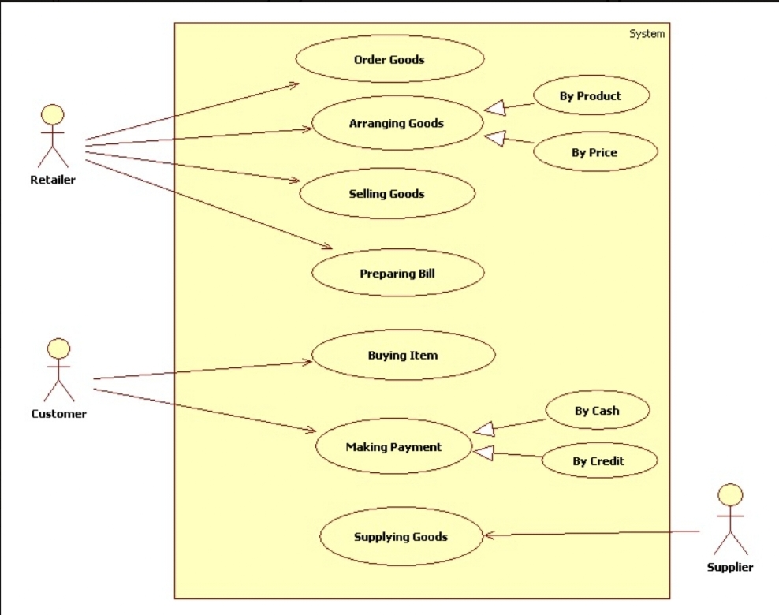

Figure 1: Use case diagram of the proposed system

The flowchart outlines the essential functionalities of an RMS, providing a clear visual representation of how users interact with the system to manage inventory, process sales, maintain customer data, generate reports, and ensure system security.

## **4.2 Module Description**

1. **Inventory Management**: This helps keep track of all the products in the store. It knows when to order more and where to put things on the shelves.
2. **Point of Sale (POS):** Think of this as the cash register. It's where you ring up customer purchases, take payments, and print receipts.
3. **Customer Management**: This is where you keep information about your customers, like their names and what they like to buy. It's like your store's memory.
4. **Reports & Analytics**: This part is like a detective. It looks at all the sales and inventory data to figure out what's happening in the store. It helps you make smart decisions.
5. **Security & Access Control**: It's like the bouncer at a club. This module keeps the bad guys out and decides who's allowed to do what in the system.

### **4.2.1 Modules**

In this section you should discuss the modules and sub-modules in detail

1. **Inventory Management:**
   1. Product Management: This is like your store's product catalog. It keeps a list of all the items you sell, including details like names, prices, and descriptions.
   2. Stock Control: It's like your inventory detective. It helps you know how much of each product you have in the store and whether you need to order more.
   3. Supplier Management: It's like your contact book for suppliers. You can keep their information here and order products when you're running low.
2. **Point of Sale (POS):**
   1. Checkout: This is where you scan products, add them up, and tell customers how much they need to pay.
   2. Payment Processing: Think of it as your cash register. It handles cash, cards, and digital payments.
   3. Receipt Generation: It's like the receipt printer that gives customers a record of what they bought.
3. **Customer Management:**
   1. Customer Information: This is like your customer book. You keep records of your customers here, including their names, contact info, and purchase history.
   2. Loyalty Programs: Think of it as customer rewards. You can give points or discounts to loyal customers.
4. **Suppliers and Partners:**
   1. Suppliers and partners are stakeholders in the sense that they interact with the retailer's system through processes such as order fulfillment, supply chain management, and collaborative promotions.
   2. A retail management system that facilitates efficient communication and collaboration with suppliers and partners can improve supply chain visibility, reduce lead times, and strengthen relationships.
5. **Security & Access Control:**
   1. User Management: This is like your security guard. It lets you decide who can use the system and what they can do.
   2. Access Permissions: It's like the key to different rooms in your store. You can control who gets access to different parts of the system.

### **4.3 Hardware and Software Components**

**4.3.1 Hardware :-**

**1.** RFID Sensor - RFID technology can identify and track inventory items. Instead of a printed barcode, RFID uses a tiny computer chip called a tag that stores vast amounts of information, including item number, inventory entry date, size, location, color, type, origin and price.



Figure 2 :- RFID SENSOR

1. ESP32 - The ESP32 microcontroller offers features such as Wi-Fi, Bluetooth, timers, ADCs, DACs, touch sensors, and a Hall effect sensor . It also has two 240MHz cores, making it powerful for various applications .

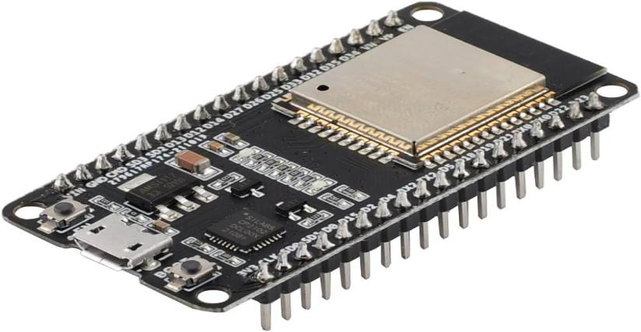

Figure 3 :- ESP32

**4.3.2 Software :-**

1. Front end :- For front end we have used Flutter. In flutter we have created our app front end which makes our app more flexible and ease for development. Not only it speeds up the development but eliminates the need for writing code for Android and iOS applications separately. App version updates and UI content upgradation can also happen super-fast with Flutter. Retail businesses can use the same code-base for Android and iOS through Flutter app development.
2. Back end :- For back end we have used Firebase. It offers us No-SQL cloud database that allows us to store and sync data in real time across multiple clients.With the help of a real-time database, there won't be a need to build one's own database or API as the framework will take care and manage it all.

### **4.4 Flow Diagram**

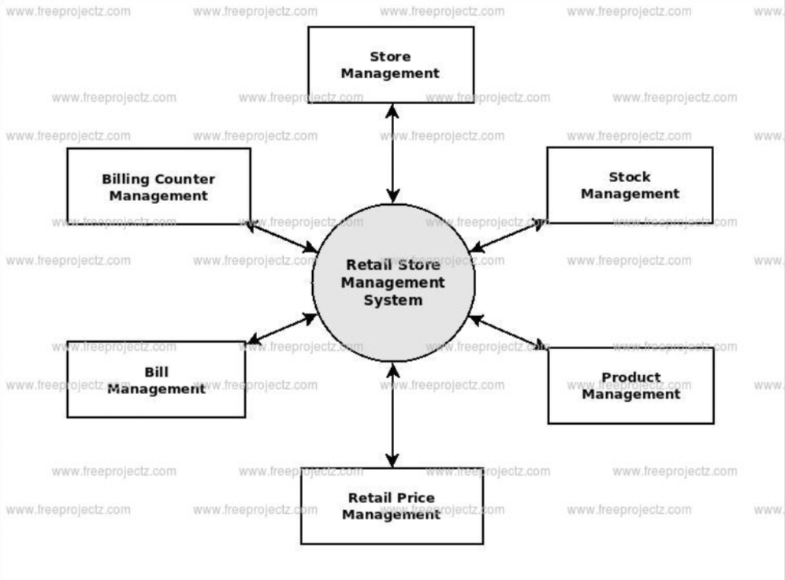

Figure 4: Flow Diagram

The figure 4 can be clearly understand the process of Retail Management System. In this we have Store Management, Stock Management, Product Management and Billing Process. Every Process is directly connected through Management System.

### 

### **4.5 E-R Diagram**

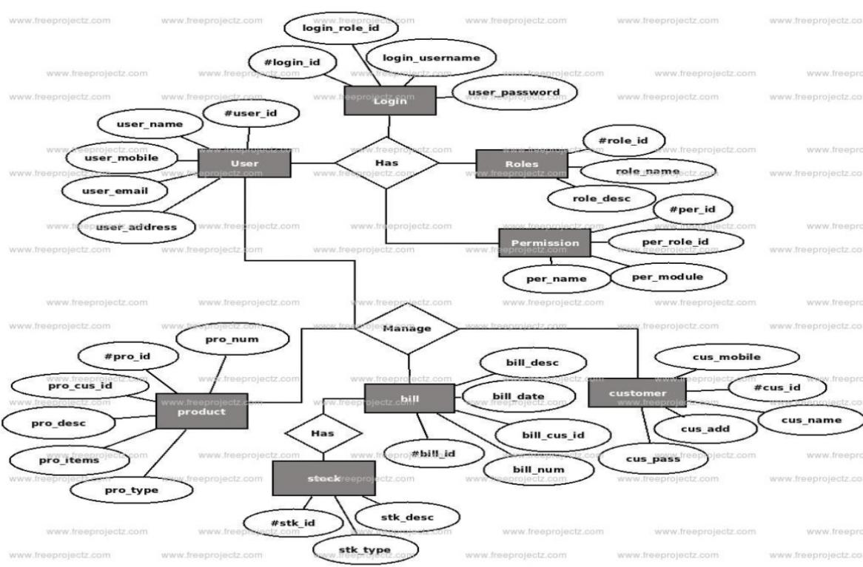

Figure 5: ER Diagram

The figure 5 shown is ER diagram. In this we have different types of entities with some different attributes as follows :-

1. Login - It is the login page of our app, In that we have customer’s login id, username, user password. After entering details it will take you to the main menu page.
2. User - To enter our app user has to put some of his/her details in the app such as email, mobile number, id and username.
3. Product - In this we keep the record of products, to cart your products we have to check the product name, id and type of the products.

### 

### **4.6 Database Design**

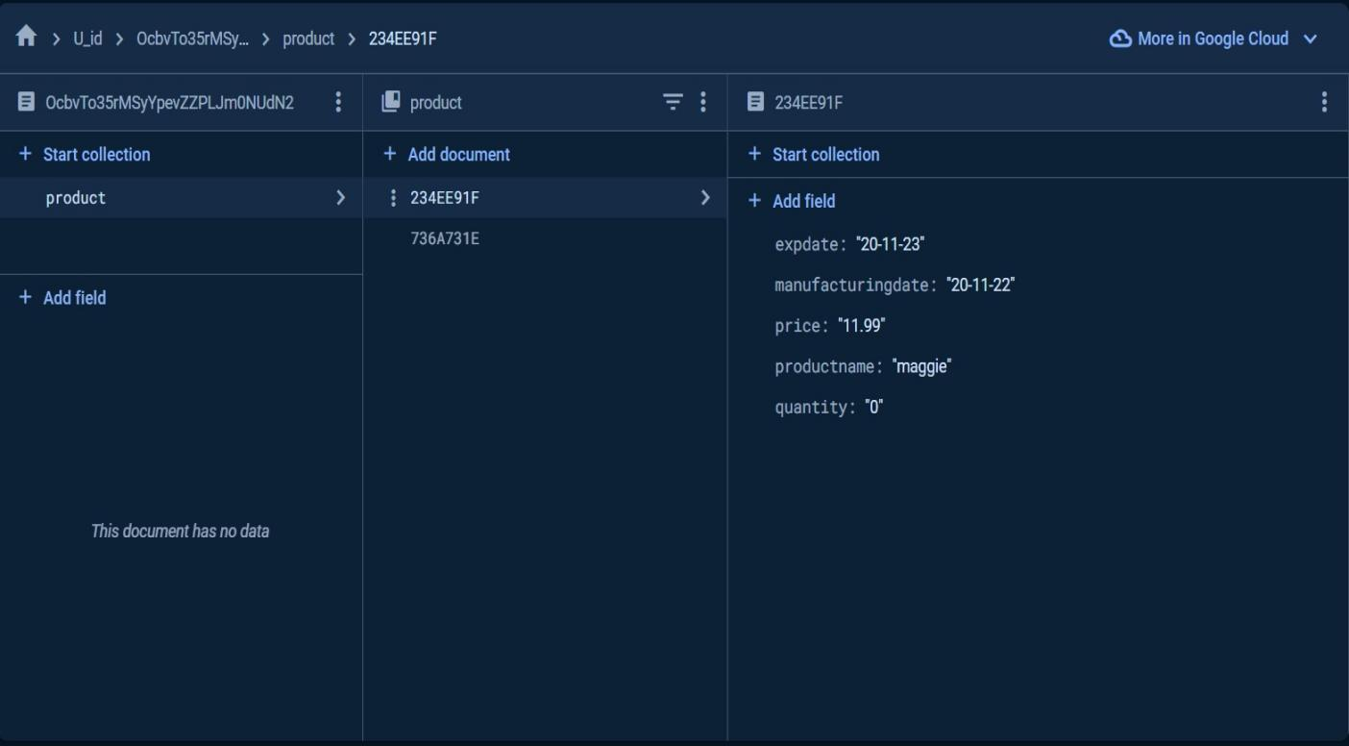

Figure 6 : Screen shot of database

The figure 6 shows our database design. From this we can check the quantity of products, we can update the items, we can set the price of it and more can be done by using database.

### 

### **4.7 Codes and App Interface**

**4.7.1 Code**

1. Homepage

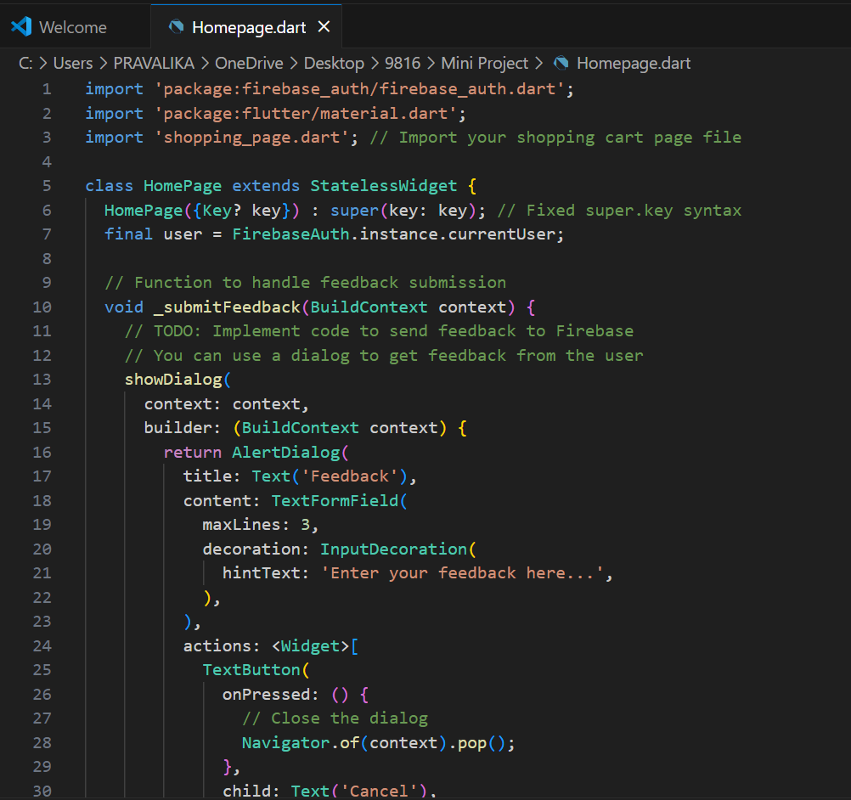

1. Login Page

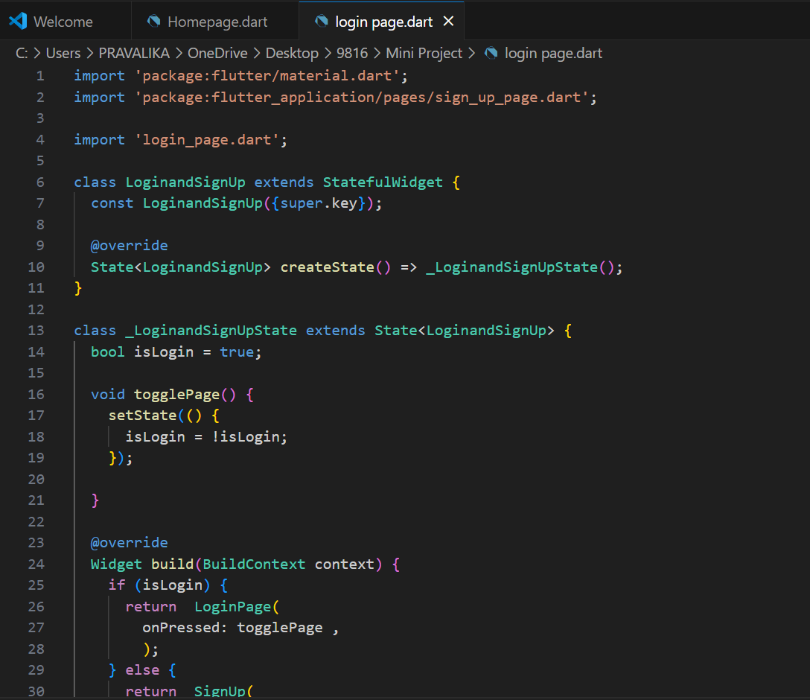

### **4.7.2 App Interface**

1. Login Page

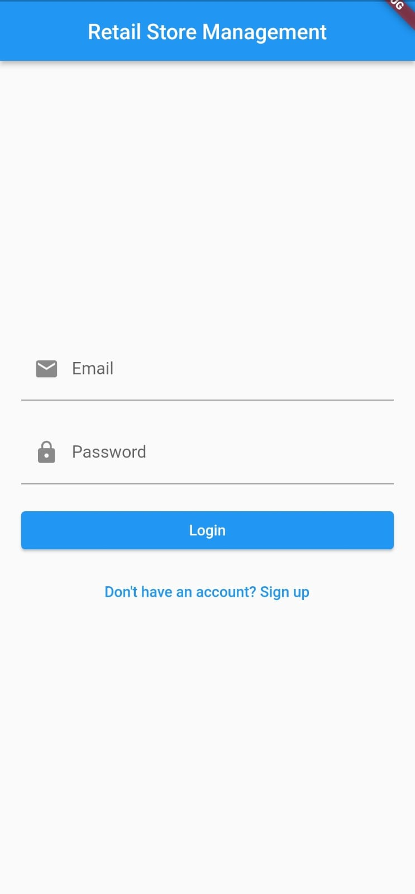 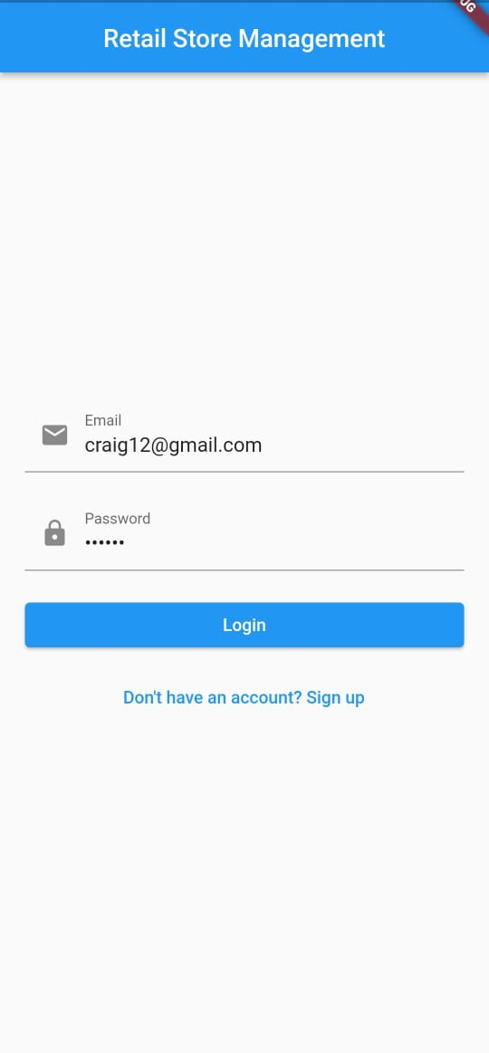

Figure 7 : Login Page

So the figure 7 shows the app interface which is the login page of our app. In this we have to login using email id as well as password. It also check whether the given details are correct or not i.e Id and password. It also shows whether the Id is correct or not same goes for password.

1. Shopping Cart

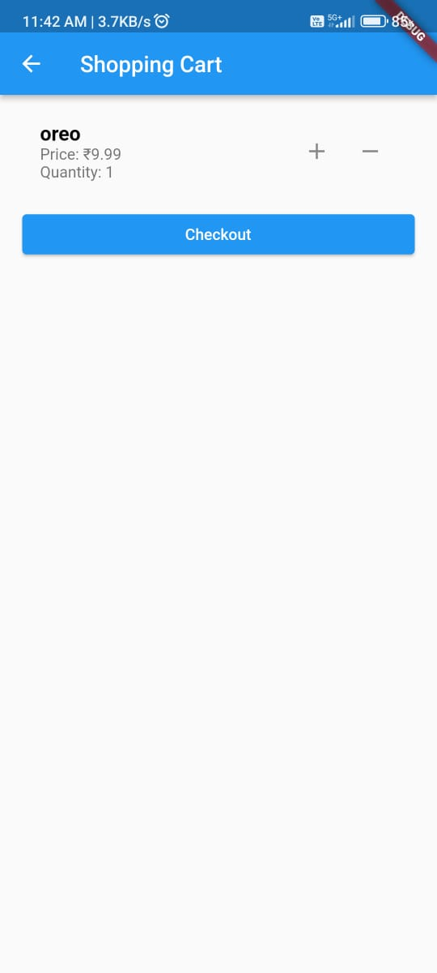

Figure 8 : Shopping cart

So the figure 8 shows the shopping cart of our app. In this we can have shop our items . It also shows the options to cart items with quantities as well as price of items. It even shows whether the item is available or out of stock.

### 

**4.8 Algorithm**

Proposed Algorithm - TEST

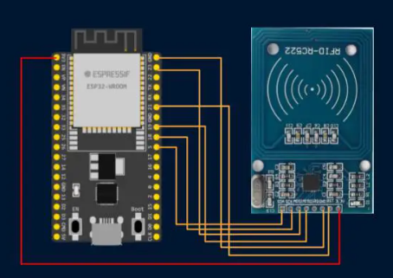

Figure 9 :- Connection between RFID and ESP32

The figure 9 shows the Interfacing of an RFID RC522 module with an ESP32 allows you to read information from RFID/NFC tags. The RC522 module communicates with the ESP32 via SPI (Serial Peripheral Interface). By connecting the appropriate pins and writing code, you can read the unique identifiers (UIDs) of RFID tags. These tags can be used for various applications such as access control, inventory management, and more. If you’d like more detailed instructions or sample code, feel free to explore the tutorials linked in my previous responses

**Chapter 5**

**Implementation**

## **5.1 Methodology**

* Planning: First, you decide what products to sell and how to organize the store. It's like deciding what ingredients to use in a meal.
* Organizing: You put products on the shelves, set up the cash register, and make sure everything has a place. It's like arranging your kitchen and cooking tools.
* Stocking: This is about keeping products in stock, so you never run out. It's like making sure you always have enough ingredients to cook.
* Selling: When customers come in, you use the cash register to ring up their purchases and give them a receipt. It's like serving the dishes you cooked.
* Customer Care: You take care of customers by offering good service and maybe giving them rewards for coming back. It's like making your guests feel welcome and appreciated.
* Checking: You regularly check how the store is doing, like how much money you're making and what products are popular. It's like tasting your food to make sure it's delicious.
* Safety and Security: You keep the store safe from problems and protect customer information. It's like making sure your kitchen is clean and your recipes are secret.
* Improvement: If something's not working well, you figure out how to do it better. After so many efforts it will work for sure.

**5.2 Output**

  Figure 10 :- Login Page

 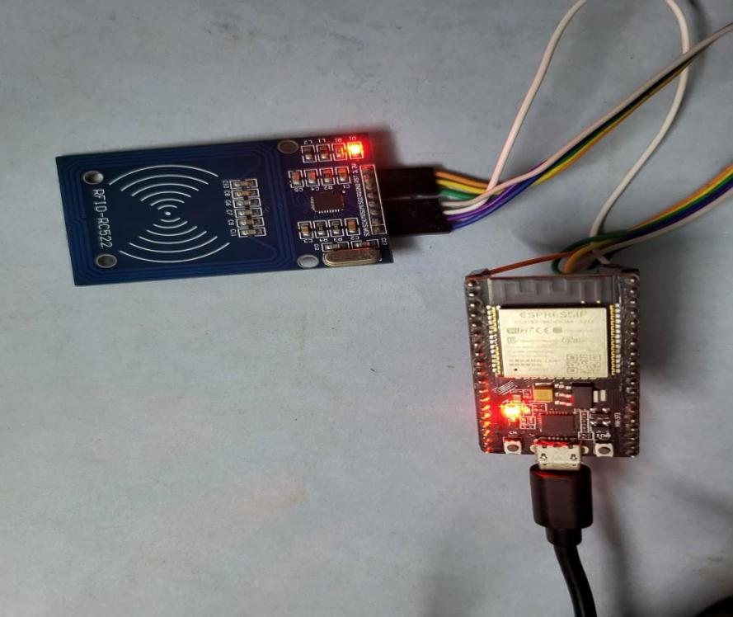

Figure 11 :- Shopping Cart Figure 12:-Connection between RFID and ESP32

**Chapter 6**

**Conclusion And Future Enhancements**

### **6.1 Conclusion**

The Retail Management System project brings order and efficiency to retail stores. It helps store owners manage products, serve customers, and keep things running smoothly. With Retail Management System, stores can stock the right products, make sales go smoothly, and keep customers happy. It's like having a smart helper that takes care of the hard work so everyone can enjoy shopping and running the store. In the end, Retail Management System makes the retail world a better place for both customers and store owners.It's a computer system that helps store owners and their staff keep things organized and customers happy. This system is implemented by using Flutter, HTML and React for frontend and for backend SQL is used. It will be easier to do shopping.

### **6.2 Future Enhancements**

Continuously improving and expanding a Retail Management System is essential to meet the evolving needs of online shopping facilities. Here are additional features that can be considered for future enhancements:

* More Automation: RMS can do more tasks on its own, like reordering products when they run out. It's like having a robot helper in the store.
* Online Shopping: RMS can help stores sell stuff online, so customers can shop from home. It's like having a store that's open 24/7.
* Better Customer Insights: RMS can learn even more about what customers like to buy, so stores can offer exactly what people want. It's like a mind reader for shopping.
* Mobile Apps: RMS can have apps for phones, making it easy for customers to check prices and shop while on the go. It's like having the store in your pocket.
* Environmental Friendly: RMS can help stores be more eco-friendly by reducing waste and using less paper. It's like helping the planet while shopping.
* Faster Service: RMS can make checkout even faster, so customers spend less time waiting in line.

# **References**

1. A. P. C. W. B . Helmsman and H. Ramakrishna, “An application-specific protocol architec- ture for wireless micro-sensor networks,” *IEEE Transactions on Wireless Communications*, vol. 1, pp. 660–670, 2002.
2. A. C. W. R. Helmsman and H. Ramakrishna, “Energy-efficient communication protocol for wireless micro-sensor networks,” in *Proc. The Hawaii International Conference on System Sciences*, Hawaii, 2002, pp. 3005–3014.
3. D. E. B. Krishnamachari and S. Wicker, “Modeling data-centric routing in wireless sensor networks,” *Wireless Communications*, vol. 1, pp. 660–670, 2002.
4. V. Godbole, “Performance analysis of ant-net-la protocol for ad-hoc networks based on disas- ter area mobility model,” *Radio Electronics Society, Vietnam (REV) Journal of Electronics and Communications*, vol. 3, no. 1-2, pp. 28–39, 2013.
5. J. S. Baras and H. Mehta, “A probabilistic emergent routing algorithm for mobile ad hoc networks,” 2003.
6. D. E. Goldberg, Genetic Algorithm in a Search Optimization and Machine Learning. Ad- dison Wesley, Boston, 1989.
7. G. D. Caro and M. Dorigo, “Mobile agents for adaptive routing,” in *proc. The Thirty-First Hawaii International Conference on System Sciences*, august 1998, pp. 74–83.
8. V. Godbole, “Performance analysis of bio-inspired routing protocols based on random way- point mobility model,” *Defence S & T Technical Bulletin*, vol. 2, pp. 114–134.
9. P. Lalbakhsh, B. Zaeri, and M. N. Fesharaki, “Applying nonlinear learning scheme on antnet routing algorithm,” in *Proc. Annual Meeting of the North American Fuzzy Information Processing Society (NAFIPS)*, 2010, pp. 1–6.